9 SCIENCE 2016

CHEMISTRY TEST TWO

Name: ____________________ Mark: /54

Percentage: %

SECTION A: MULTIPLE CHOICE (28 marks)

Select the most correct answer for each question below.

1. A B C D 17. A B C D
2. A B C D 18. A B C D
3. A B C D 19. A B C D
4. A B C D 20. A B C D
5. A B C D 21. A B C D
6. A B C D 22. A B C D
7. A B C D 23. A B C D
8. A B C D 24. A B C D
9. A B C D 25. A B C D
10. A B C D 26. A B C D
11. A B C D 27. A B C D
12. A B C D 28. A B C D
13. A B C D
14. A B C D
15. A B C D
16. A B C D
1. Distilled water has a pH of:
(a) 9.
(b) 8.
(c) 6.
(d) 7.

2. A correct definition for the term pH would be:

(a) A scale used to measure the number of hydrogen ions in a solution.
(b) A scale used to measure the concentration of hydrogen ions in a solution.
(c) A scale used to measure the concentration of hydroxide ions in a solution.
(d) A scale used to measure the number of hydroxide ions in a solution.

3. Acids release hydrogen ions (H⁺) into solution. Use this information to identify which of the following substances could NOT be an acid.

(a) HCOOH
(b) Fe₂O₃
(c) H₂CO₃
(d) NaHSO₄

4. What is a solution that has an excess of H⁺ (hydrogen) ions?

(a) pH.
(b) Acid.
(c) Neutral.
(d) Base.

5. The pH scale is actually measuring the number of H⁺ ions in a solution. If there are a lot of H⁺ ions, the pH is very _______________.

(a) High.
(b) Low.
(c) Neutral.
(d) Neither.

6. A _________ is what scientists use to measure how basic or acidic a liquid is. The ________ ranges from values very close to 0 through to 14.

(a) Ruler.
(b) Colour scale.
(c) Indicator.
(d) pH scale.

7. What is needed for complete combustion to take place?

(a) A good supply of oxygen.
(b) A very high temperature.
(c) A fuel with lots of carbon in it.
(d) A good supply of hydrogen.

8. Which is the most dangerous product of incomplete combustion?

(a) Carbon monoxide.
(b) Carbon.
(c) Water.
(d) Carbon dioxide.

9. Rusting is a special term given to the corrosion of which metal?

(a) Zinc.
(b) Copper.
(c) Nickel.
(d) Iron.

10. What conditions are required for rusting to take place?

(a) Water only.
(b) Oxygen only.
(c) Water and oxygen.
(d) Water and carbon dioxide.

11. Corrosion is a chemical reaction that involves:

(a) The inside of the object changing from an element to a compound.
(b) The surface of the object changing from an element to a compound.
(c) Nothing happens.
(d) The surface of the object changes from one element into another element.

12. What name is given to radiation that is always around us?

(a) Electromagnetic radiation.
(b) Background radiation.
(c) Natural radiation.
(d) Ionic radiation.

13. Isotope A has a half-life measured in minutes, whereas isotope B has a half-life of millions of years. Which is more radioactive?

(a) Isotope A.
(b) Isotope B.
(c) Both are equally dangerous.
(d) It depends on the sample size.

14. What is meant by the half-life of a radioactive sample?

(a) The time taken for the overall mass of the radioactive sample to half.
(b) The time taken for the activity of the radioactive sample to fall to a safe level.
(c) The time taken for the activity of the radioactive sample to half.
(d) The time taken for the overall mass of the radioactive sample to increase.

15. Where does radioactivity come from?

(a) From stable isotopes.
(b) From unstable radioactive isotopes.
(c) From all of the elements.
(d) From atoms.

16. Atoms that have the same number of protons but different numbers of neutrons are called?
(a) Electrons.
(b) Isotopes.
(c) Protons.
(d) Stable atoms.

17. An isotope of manganese has 25 protons and 30 neutrons. What is the mass number of this isotope?

(a) 25.
(b) 30.
(c) 55.
(d) 5.

18. Select the most correct definition for the term ‘radioactive’.

(a) The process of emitting radiation.
(b) The process of absorbing heat.
(c) The time it takes for half of the nuclei to decay.
(d) The process of an atom changing into a different type of atom.

19. Select the most correct definition for the term radioisotope’.

(a) An isotope with electrons that may undergo a nuclear reaction.
(b) An isotope with a nucleus that may undergo a nuclear reaction.
(c) An atom with electrons that may undergo a nuclear reaction.
(d) An atom with a nucleus that may undergo a nuclear reaction.

20. Select the most correct definition for the term ‘transmutation’.

(a) A nuclear reaction process that increases the half-life of the nuclei.
(b) A nuclear reaction process that converts one type of atom into a different type of atom.
(c) A nuclear reaction process that converts the electrons around an atom into protons.
(d) A nuclear reaction process that reduces the half-life of the nuclei.

21. Radiation that travels through a vacuum as waves rather than particles is known as:

(a) Nuclear radiation.
(b) Magnetic radiation.
(c) Electric radiation.
(d) Electromagnetic radiation.

Questions 22-26 refer to the diagram below.

22. The diagram shows three types of:
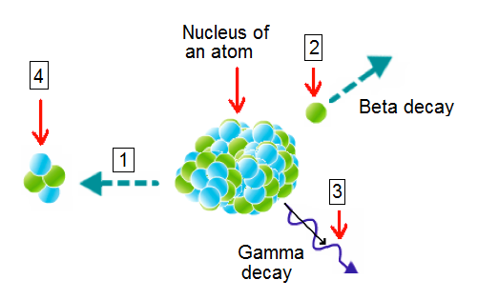
(a) Atom decay.
(b) Proton decay.
(c) Nuclear decay.
(d) Nucleus decay.

23. Label (4) represents:

(a) An alpha particle.
(b) A beta particle.
(c) An electron.
(d) A nucleus.

24. Label (3) represents:

(a) A beta particle.
(b) Gamma decay.
(c) Gamma particle.
(d) Gamma rays.

25. Label (2) represents:

(a) An alpha particle.
(b) A beta particle.
(c) An electron.
(d) Gamma rays.

26. Label (1) represents:

(a) Alpha decay.
(b) Beta decay.
(c) Gamma decay.
(d) Atom decay.

27. Select the incorrect statement below.

(a) Nuclear radiation and nuclear decay refer to the same process.
(b) Nuclear decay causes the nucleus of an atom to change.
(c) Nuclear radiation causes the nucleus of an atom to change.
(d) Nuclear radiation causes electrons to leave an atom.

28. Gamma rays are produced when:

(a) Protons and neutrons in the nucleus rearrange.
(b) Protons and electrons in the nucleus rearrange.
(c) Electrons around the nucleus rearrange.
(d) Neutrons in the nucleus rearrange.

SECTION B: SHORT ANSWER (26 marks)

29. Fill in the missing words. (4 marks)
Beryllium

Acids turn __________ litmus paper a ____________ colour.

Bases turn __________ litmus paper a ____________ colour.

30. Write the general equation for the reaction between an acid and a metal. (1 mark)

___________________ + ___________________ → __________________ + _____________________

31. Write the general equation for the reaction between an acid and a base
(neutralisation reaction). (1 mark)

___________________ + ___________________ → __________________ + _____________________

32. Write the general equation for the reaction between an acid and a carbonate. (1 mark)

_______________ + ________________ → _______________ + _________________ +______________

33. Look at the substances below. Write the letter for each substance under the correct pH line to demonstrate where they sit on the pH scale. (8 marks)
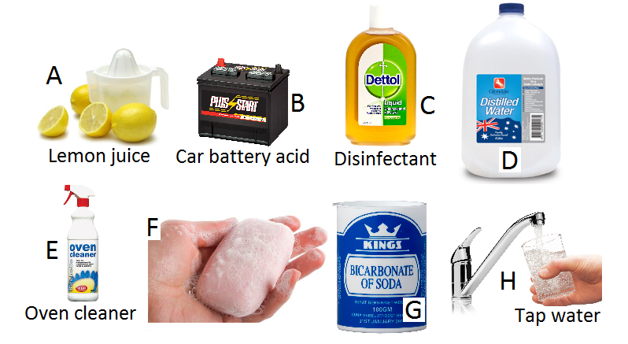

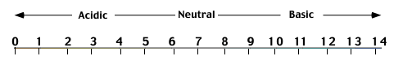

34. List three properties of acids. (3 marks)

⬥ _______________________________________________

⬥ _______________________________________________

⬥ _______________________________________________

35. List three properties of bases. (3 marks)

⬥ _______________________________________________

⬥ _______________________________________________

⬥ _______________________________________________

36. Every liquid is either an acid or a base. True or False (1 mark)

37. Acids and bases can combine to create water and salts. True or False (1 mark)

38. What is released from an atom during alpha decay? (1 mark)

__________________________________________________________________

39. What is released from an atom during beta decay? (1 mark)

__________________________________________________________________

40. What is released from an atom during gamma decay? (1 mark)
__________________________________________________________________

Only work on this page after you have attempted EVERY question in the test!

